**Exercise – 1 Setting Up Junit**

**Steps:**

1. Open VS Code editor.
2. Ctrl+Shift+P -> Maven : New Project
3. Choose the archetype.
4. Choose the groupId and artefactid
5. Click enter and you can see VS Code creates a new project folder.

**Go to pom.xml file and change the dependencies as given**

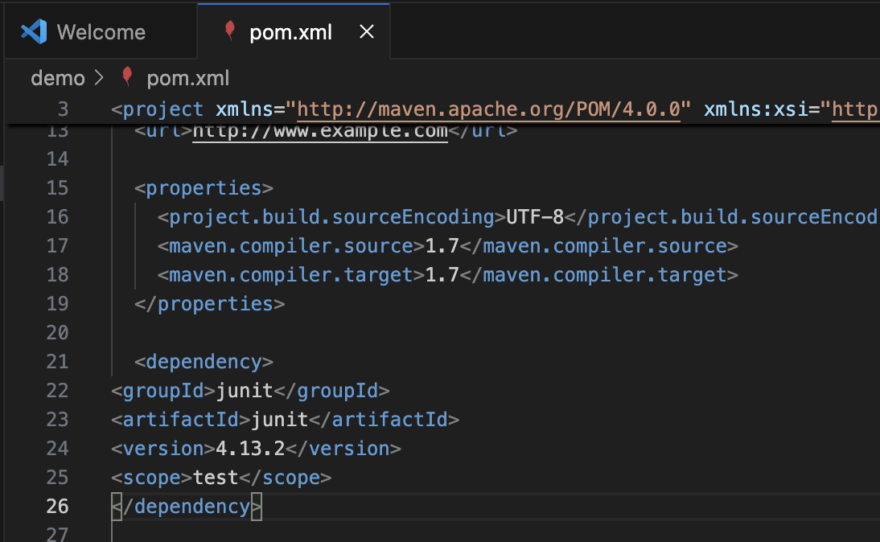

**Creating a new Test class and testing the Java Methods in App.java**

